This is also the Algebra 2B unit 5 portfolio. Student Name:____________________

These are problems from units 2-4 of Algebra 2B which are helpful preparation for the semester final exam. Please print these pages. Show your work in the space provided for each problem. You do not have to type your response, handwritten is fine. Please upload your completed file into the Algebra 2B unit 5 lesson 6 (Robot) Portfolio dropbox.

1. What is the simplest form of the radical expression?$\sqrt{625x^{20}y^{8}}$

2. How can you write the expression with a rationalized denominator? $\frac{\sqrt[3]{49}}{\sqrt[3]{7}}$

3. What is the solution the equation? $9={(x-2)}^{2/3}$

4.$Let f\left(x\right)= x^{2}+7 and g\left(x\right)=\frac{x-3}{x}$ $Find (f∘g)(-8)$

5. Graph the function. $y=3\sqrt{x-2}$
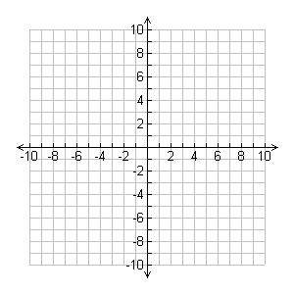

6. Is the relationship between the variables in this table a direct variation, an inverse variation, or neither. If it is a direct or inverse variation, write a function to model it.
x | 2 | 4 | 6 | 8
y | 1/3 | 1/6 | 1/9 | 1/12

7. A group of students are going to attend a concert. The cost per person varies inversely and depends on the number of people attending the concert. It will cost $75 per ticket if 2000 people attend. How much will the tickets be if 5000 people attend?

8. Write the equation for the translation of $y= \frac{7}{x}$ that has asymptotes at $x=-3$ and $y = 17$.

9. Describes the discontinuities and asymptotes for the rational function. $y=\frac{\left(x-3\right)((x+2)}{\left(x+4\right)\left(x-4\right)(x+2)}$

10. What is the quotient in simplified form? State any restrictions on the variable.
$$\frac{(6-x)}{x^{2}-3x-28}÷\frac{x^{2}+5x-36}{x^{2}-36}$$

11. What is the 70th term of the sequence that begins $-3, 1, 5, 9…$?

12. The 3rd term in a geometric sequence is 40. The 5th term is 10. What the possible values of the 4th term?

13. Find the sum of the following series.
$$\sum_{n=1}^{22}{(4n-9)}$$

14. What is $S_{8}$ for $4 + 8 + 16 + …$

15. Tyler begins funding a college education for his son. He saves $1000 the first year. Each year he saves 5% more than the previous year. How much money will be in the college fund at the end of 18 years?

